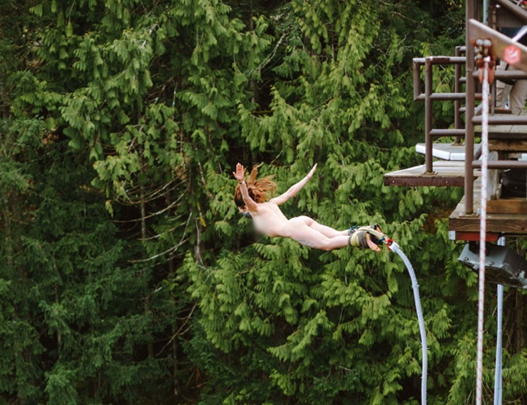
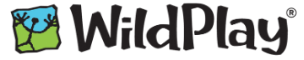

16th Annual Naked Bungy Jump for Mental Health! Please support me in raising funds and awareness for mental health.
Every dollar is matched up to $40K and goes directly to mental health support programs! Thank you!

PLEDGE A PARTICIPANT!
The Naked Bungy Jump for MHRP is an important fundraising event for Mental Health Awareness Partners Vancouver Island. Now in its sixteenth year, the weekend continues to be a leading contribution of funds that help to provide life-saving mental health programs on Vancouver Island.

TWO MORE COOL REASONS TO PLEDGE:
1. Thanks to the support of an anonymous donor, every pledge you turn in before you Bungy Jump will be matched!
2. Your pledges could earn a FREE* plunge! Raise $200 in pledges before you Bungy Jump and you’ll get your leap for free!

HELP US REACH OUR GOAL OF $40,000!
We hope that each participant will gather $125 in pledges so that together we can raise over $40,000 to fund programs and services in 2022 – including individual and family support, peer led programs, and education to thousands of people who reach out for help each year.
*Donations and completed forms must be received by MHRP’s Canada Helps page no later than March 4th, 2022. Pre-booked Bungy Jump fees will be refunded at event check‐in for participants confirmed by MHRP to have turned in $200+ in pledges for the Naked Bungy Jump event 2022.

COLLECTING PLEDGES IS EASY:
- Sign up to collect pledges and share your story online via Canada Helps! This is an easy way to gather the most pledges, and it is convenient for donors – they can pledge you right on the website. Donations are tracked and go directly towards the Naked Bungy Jump for MHRP fund. You can see how much you raise, and even engage in some friendly competition.
- Visit MHRP’s Canada Helps page (link) and select “Start a Fundraiser”
- Create your personal fundraising page, mention why you are jumping and share on social media. You can keep it simple or get creative!
- Share, Share, Share! And remember to tag #WildPlayNanaimo, #NakedBungy2022, or #MentalHealth. Be part of the movement to end mental health stigma!

- Use the form below to collect pledges in person. Asking someone (or everyone you see!) “Would you pledge my Naked Bungy Jump for MHRP?” is all it takes to get some support and start an interesting conversation. Use the MHRP Pledge Form below to record their promise, and cash/cheques received.
- Return your completed pledge form, with all cash/cheque donations to MHRP before March 4th, 2022, or at WildPlay Nanaimo before your jump.

Don’t forget to reserve your bungy jump online at WildPlay Nanaimo:
https://book.singenuity.com/5/details/activity/138
Click on the “Naked Bungy Jump” link and choose your desired time slot.

Do you have question about the event or collecting pledges? Need a printed copy of the form? Contact MHRP at admin@mhrp.ca, 250‐384‐4225, or visit us in Victoria at 941 Kings Rd. 9am-4pm Monday to Friday.

PLEDGE FORM

Donor name: | Mailing address  (for tax receipts of $20 or more): | Amount donated:

SPECTATOR DONATION FORM ($15 per spectator!)

Donor name: | Mailing address  (for tax receipts of $20 or more): | Amount donated:

